DSuC Mini Project

(Bhuvi Kataria DS-001)

16. Kalnirnay: Conversion from Gregorian to Hindi calendar.

#include <stdio.h>
#include <stdlib.h>
#include <string.h>

struct Month {
int gMonth;
char hMonth[20];
struct Month* next;
};

struct Month* head = NULL;

struct Month* createNode(int gMonth, char hMonth[]) {
struct Month* newNode = (struct Month*)malloc(sizeof(struct Month));
newNode->gMonth = gMonth;
strcpy(newNode->hMonth, hMonth);
newNode->next = NULL;
return newNode;
}

void insert(int gMonth, char hMonth[]) {
struct Month* newNode = createNode(gMonth, hMonth);

if (head == NULL) {
head = newNode;
} else {
struct Month* temp = head;
while (temp->next != NULL)
temp = temp->next;
temp->next = newNode;
}
}

void createMapping() {
insert(1, "Paush");
insert(2, "Magh");
insert(3, "Phalgun");
insert(4, "Chaitra");
insert(5, "Vaishakh");
insert(6, "Jyeshtha");
insert(7, "Ashadh");
insert(8, "Shravan");
insert(9, "Bhadrapad");
insert(10, "Ashwin");
insert(11, "Kartik");
insert(12, "Margashirsha");
}

void convert(int day, int month, int year) {
struct Month* temp = head;

while (temp != NULL) {
if (temp->gMonth == month) {
printf("\nHindi Date (Approx): %d %s %d\n",
day, temp->hMonth, year + 57);
return;
}
temp = temp->next;
}

printf("Invalid month!\n");
}

void display() {
struct Month* temp = head;

printf("\nMonth Mapping:\n");
while (temp != NULL) {
printf("Gregorian %d -> Hindi %s\n", temp->gMonth, temp->hMonth);
temp = temp->next;
}
}

int main() {
int day, month, year, choice;

createMapping();

do {
printf("\n--- Kalnirnay Conversion System ---\n");
printf("1. Convert Date\n");
printf("2. Display Mapping\n");
printf("3. Exit\n");
printf("Enter choice: ");
scanf("%d", &choice);

switch (choice) {
case 1:
printf("Enter Day Month Year: ");
scanf("%d %d %d", &day, &month, &year);
convert(day, month, year);
break;

case 2:
display();
break;

case 3:
printf("Exiting...\n");
break;

default:
printf("Invalid choice!\n");
}

} while (choice != 3);

return 0;
}

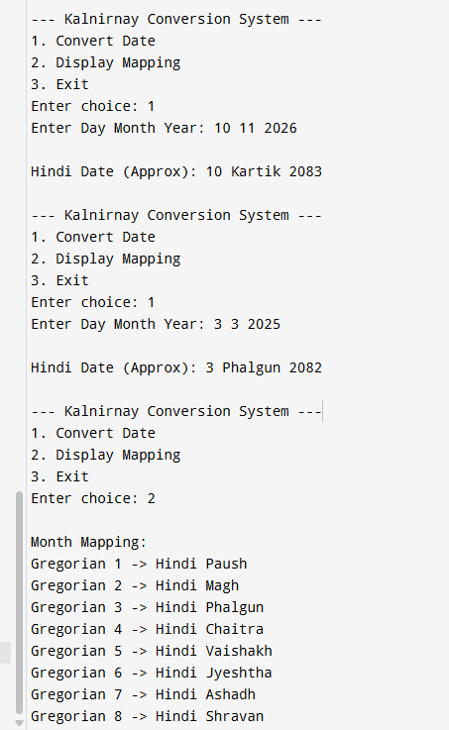

17. Create a basic system that recommends irrigation time based on soil type and crop, using linked lists to store crop data.

#include <stdio.h>
#include <stdlib.h>
#include <string.h>

struct Node {
char crop[50];
char soil[50];
int time;
struct Node* next;
};

struct Node* head = NULL;

struct Node* createNode(char crop[], char soil[], int time) {
struct Node* newNode = (struct Node*)malloc(sizeof(struct Node));
strcpy(newNode->crop, crop);
strcpy(newNode->soil, soil);
newNode->time = time;
newNode->next = NULL;
return newNode;
}

void insert(char crop[], char soil[], int time) {
struct Node* newNode = createNode(crop, soil, time);

if (head == NULL) {
head = newNode;
} else {
struct Node* temp = head;
while (temp->next != NULL)
temp = temp->next;
temp->next = newNode;
}
}

void display() {
struct Node* temp = head;

if (temp == NULL) {
printf("\nNo data available.\n");
return;
}

printf("\n--- Crop Records ---\n");
while (temp != NULL) {
printf("Crop: %s | Soil: %s | Time: %d hrs\n",
temp->crop, temp->soil, temp->time);
temp = temp->next;
}
}

void recommend(char crop[], char soil[]) {
struct Node* temp = head;
int found = 0;

while (temp != NULL) {
if (strcmp(temp->crop, crop) == 0 &&
strcmp(temp->soil, soil) == 0) {

printf("\nRecommended irrigation time: %d hours\n", temp->time);
found = 1;
break;
}
temp = temp->next;
}

if (!found) {
printf("\nNo recommendation found for given input.\n");
}
}

int main() {
int choice, time;
char crop[50], soil[50];

do {
printf("\n===== Irrigation System =====\n");
printf("1. Add Crop Data\n");
printf("2. Display All Data\n");
printf("3. Get Recommendation\n");
printf("4. Exit\n");
printf("Enter choice: ");
scanf("%d", &choice);

switch (choice) {
case 1:
printf("Enter crop name: ");
scanf("%s", crop);
printf("Enter soil type: ");
scanf("%s", soil);
printf("Enter irrigation time (hours): ");
scanf("%d", &time);

insert(crop, soil, time);
break;

case 2:
display();
break;

case 3:
printf("Enter crop name: ");
scanf("%s", crop);
printf("Enter soil type: ");
scanf("%s", soil);

recommend(crop, soil);
break;

case 4:
printf("Exiting...\n");
break;

default:
printf("Invalid choice!\n");
}

} while (choice != 4);

return 0;
}
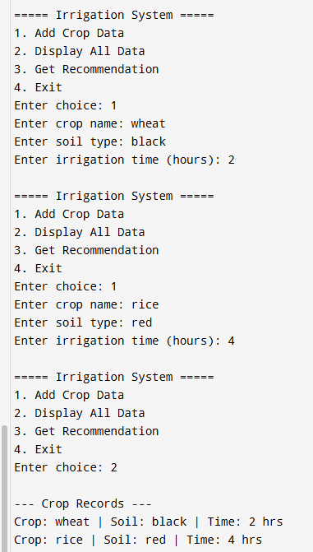

18. Design and implement a queue-based appointment management system for a clinic that handles patients in the order of their arrival. The system should maintain a First-Come, FirstServed (FCFS) queue for patients and provide options to add new patients, view the next patient to be treated, serve (remove) a patient once treated, and display the list of all waiting patients.

#include <stdio.h>
#include <stdlib.h>
#include <string.h>

struct Patient {
int id;
char name[50];
struct Patient* next;
};

struct Patient* rear = NULL;

struct Patient* createPatient(int id, char name[]) {
struct Patient* newNode = (struct Patient*)malloc(sizeof(struct Patient));
newNode->id = id;
strcpy(newNode->name, name);
newNode->next = NULL;
return newNode;
}

void addPatient(int id, char name[]) {
struct Patient* newNode = createPatient(id, name);

if (rear == NULL) {
rear = newNode;
rear->next = rear; // circular link
} else {
newNode->next = rear->next;
rear->next = newNode;
rear = newNode;
}

printf("Patient added successfully!\n");
}

void viewNextPatient() {
if (rear == NULL) {
printf("No patients in queue.\n");
return;
}

struct Patient* front = rear->next;
printf("Next Patient -> ID: %d, Name: %s\n", front->id, front->name);
}

void servePatient() {
if (rear == NULL) {
printf("No patients to serve.\n");
return;
}

struct Patient* front = rear->next;

if (rear == front) {
printf("Serving Patient -> ID: %d, Name: %s\n", front->id, front->name);
free(front);
rear = NULL;
} else {
printf("Serving Patient -> ID: %d, Name: %s\n", front->id, front->name);
rear->next = front->next;
free(front);
}
}

void displayPatients() {
if (rear == NULL) {
printf("No patients in queue.\n");
return;
}

struct Patient* temp = rear->next;

printf("\n--- Waiting Patients ---\n");
do {
printf("ID: %d, Name: %s\n", temp->id, temp->name);
temp = temp->next;
} while (temp != rear->next);
}

int main() {
int choice, id;
char name[50];

do {
printf("\n===== Clinic Appointment System =====\n");
printf("1. Add Patient\n");
printf("2. View Next Patient\n");
printf("3. Serve Patient\n");
printf("4. Display All Patients\n");
printf("5. Exit\n");
printf("Enter choice: ");
scanf("%d", &choice);

switch (choice) {
case 1:
printf("Enter Patient ID: ");
scanf("%d", &id);
printf("Enter Patient Name: ");
scanf("%s", name);
addPatient(id, name);
break;

case 2:
viewNextPatient();
break;

case 3:
servePatient();
break;

case 4:
displayPatients();
break;

case 5:
printf("Exiting...\n");
break;

default:
printf("Invalid choice!\n");
}

} while (choice != 5);

return 0;
}
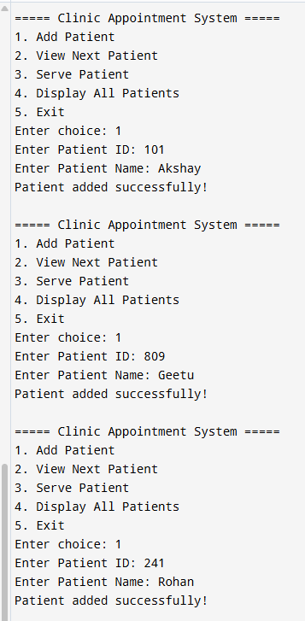

19. A program that: -
Uses efficient data structures to compute numerology -numbers for names.
Stores and organises results in a structured way.
Analyses frequency and patterns in numerology data.

#include <stdio.h>
#include <stdlib.h>
#include <string.h>
#include <ctype.h>

struct Node {
char name[50];
int number;
struct Node* next;
};

struct Node* head = NULL;

int getValue(char ch) {
ch = toupper(ch);
if (ch < 'A' || ch > 'Z') return 0;
return ((ch - 'A') % 9) + 1;
}

int calculateNumerology(char name[]) {
int sum = 0;

for (int i = 0; name[i] != '\0'; i++) {
sum += getValue(name[i]);
}

while (sum > 9) {
int temp = 0;
while (sum > 0) {
temp += sum % 10;
sum /= 10;
}
sum = temp;
}

return sum;
}

struct Node* createNode(char name[], int number) {
struct Node* newNode = (struct Node*)malloc(sizeof(struct Node));
strcpy(newNode->name, name);
newNode->number = number;
newNode->next = NULL;
return newNode;
}

void insert(char name[]) {
int num = calculateNumerology(name);
struct Node* newNode = createNode(name, num);

if (head == NULL) {
head = newNode;
} else {
struct Node* temp = head;
while (temp->next != NULL)
temp = temp->next;
temp->next = newNode;
}

printf("Name added with Numerology Number: %d\n", num);
}

void display() {
struct Node* temp = head;

if (temp == NULL) {
printf("No data available.\n");
return;
}

printf("\n--- Numerology Records ---\n");
while (temp != NULL) {
printf("Name: %s | Number: %d\n", temp->name, temp->number);
temp = temp->next;
}
}

void analyzeFrequency() {
int freq[10] = {0};
struct Node* temp = head;

while (temp != NULL) {
freq[temp->number]++;
temp = temp->next;
}

printf("\n--- Frequency Analysis ---\n");
for (int i = 1; i <= 9; i++) {
printf("Number %d appears %d times\n", i, freq[i]);
}
}

int main() {
int choice;
char name[50];

do {
printf("\n===== Numerology System =====\n");
printf("1. Add Name\n");
printf("2. Display Records\n");
printf("3. Analyze Frequency\n");
printf("4. Exit\n");
printf("Enter choice: ");
scanf("%d", &choice);

switch (choice) {
case 1:
printf("Enter Name: ");
scanf("%s", name);
insert(name);
break;

case 2:
display();
break;

case 3:
analyzeFrequency();
break;

case 4:
printf("Exiting...\n");
break;

default:
printf("Invalid choice!\n");
}

} while (choice != 4);

return 0;
}
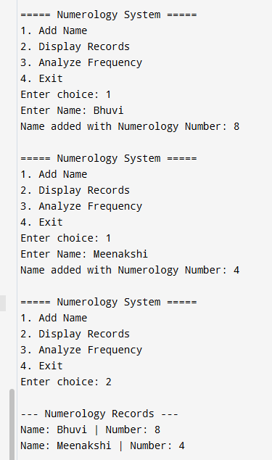

20. Create a list where students add species and their habitats, then display them grouped by pollution tolerance.

#include <stdio.h>
#include <stdlib.h>
#include <string.h>

struct Node {
char species[50];
char habitat[50];
char tolerance[10];
struct Node* next;
};

struct Node* head = NULL;

struct Node* createNode(char sp[], char hab[], char tol[]) {
struct Node* newNode = (struct Node*)malloc(sizeof(struct Node));
strcpy(newNode->species, sp);
strcpy(newNode->habitat, hab);
strcpy(newNode->tolerance, tol);
newNode->next = NULL;
return newNode;
}

void insert(char sp[], char hab[], char tol[]) {
struct Node* newNode = createNode(sp, hab, tol);

if (head == NULL) {
head = newNode;
} else {
struct Node* temp = head;
while (temp->next != NULL)
temp = temp->next;
temp->next = newNode;
}
}

void displayGrouped() {
char *levels[] = {"Low", "Medium", "High"};

for (int i = 0; i < 3; i++) {
printf("\n--- %s Pollution Tolerance ---\n", levels[i]);

struct Node* temp = head;
int found = 0;

while (temp != NULL) {
if (strcmp(temp->tolerance, levels[i]) == 0) {
printf("Species: %s | Habitat: %s\n",
temp->species, temp->habitat);
found = 1;
}
temp = temp->next;
}

if (!found) {
printf("No species found.\n");
}
}
}

void displayAll() {
struct Node* temp = head;

if (temp == NULL) {
printf("No data available.\n");
return;
}

printf("\n--- All Species Data ---\n");
while (temp != NULL) {
printf("Species: %s | Habitat: %s | Tolerance: %s\n",
temp->species, temp->habitat, temp->tolerance);
temp = temp->next;
}
}

int main() {
int choice;
char sp[50], hab[50], tol[10];

do {
printf("\n===== Species Management System =====\n");
printf("1. Add Species\n");
printf("2. Display All\n");
printf("3. Display Grouped by Pollution Tolerance\n");
printf("4. Exit\n");
printf("Enter choice: ");
scanf("%d", &choice);

switch (choice) {
case 1:
printf("Enter Species Name: ");
scanf("%s", sp);
printf("Enter Habitat: ");
scanf("%s", hab);
printf("Enter Pollution Tolerance (Low/Medium/High): ");
scanf("%s", tol);

insert(sp, hab, tol);
break;

case 2:
displayAll();
break;

case 3:
displayGrouped();
break;

case 4:
printf("Exiting...\n");
break;

default:
printf("Invalid choice!\n");
}

} while (choice != 4);

return 0;
}

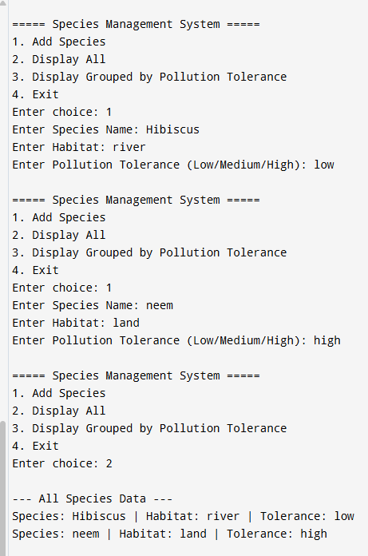

21. System to track and visualise personal health metrics (e.g., step count, calories burned, sleep).

#include <stdio.h>
#include <stdlib.h>

struct Node {
int day;
int steps;
int calories;
float sleep;
struct Node* next;
};

struct Node* head = NULL;

struct Node* createNode(int day, int steps, int calories, float sleep) {
struct Node* newNode = (struct Node*)malloc(sizeof(struct Node));
newNode->day = day;
newNode->steps = steps;
newNode->calories = calories;
newNode->sleep = sleep;
newNode->next = NULL;
return newNode;
}

void insert(int day, int steps, int calories, float sleep) {
struct Node* newNode = createNode(day, steps, calories, sleep);

if (head == NULL) {
head = newNode;
} else {
struct Node* temp = head;
while (temp->next != NULL)
temp = temp->next;
temp->next = newNode;
}
}

void display() {
struct Node* temp = head;

if (temp == NULL) {
printf("No data available.\n");
return;
}

printf("\n--- Health Records ---\n");
while (temp != NULL) {
printf("Day %d | Steps: %d | Calories: %d | Sleep: %.1f hrs\n",
temp->day, temp->steps, temp->calories, temp->sleep);
temp = temp->next;
}
}

void calculateAverage() {
struct Node* temp = head;
int count = 0;
int totalSteps = 0, totalCalories = 0;
float totalSleep = 0;

while (temp != NULL) {
totalSteps += temp->steps;
totalCalories += temp->calories;
totalSleep += temp->sleep;
count++;
temp = temp->next;
}

if (count == 0) {
printf("No data available.\n");
return;
}

printf("\n--- Averages ---\n");
printf("Avg Steps: %d\n", totalSteps / count);
printf("Avg Calories: %d\n", totalCalories / count);
printf("Avg Sleep: %.2f hrs\n", totalSleep / count);
}

void bestDay() {
if (head == NULL) {
printf("No data available.\n");
return;
}

struct Node* temp = head;
struct Node* best = head;

while (temp != NULL) {
if (temp->steps > best->steps) {
best = temp;
}
temp = temp->next;
}

printf("\n--- Best Day (Max Steps) ---\n");
printf("Day %d | Steps: %d\n", best->day, best->steps);
}

int main() {
int choice, day, steps, calories;
float sleep;

do {
printf("\n===== Health Tracker =====\n");
printf("1. Add Daily Data\n");
printf("2. Display All Records\n");
printf("3. Show Averages\n");
printf("4. Show Best Day\n");
printf("5. Exit\n");
printf("Enter choice: ");
scanf("%d", &choice);

switch (choice) {
case 1:
printf("Enter Day: ");
scanf("%d", &day);
printf("Enter Steps: ");
scanf("%d", &steps);
printf("Enter Calories: ");
scanf("%d", &calories);
printf("Enter Sleep (hours): ");
scanf("%f", &sleep);

insert(day, steps, calories, sleep);
break;

case 2:
display();
break;

case 3:
calculateAverage();
break;

case 4:
bestDay();
break;

case 5:
printf("Exiting...\n");
break;

default:
printf("Invalid choice!\n");
}

} while (choice != 5);

return 0;
}

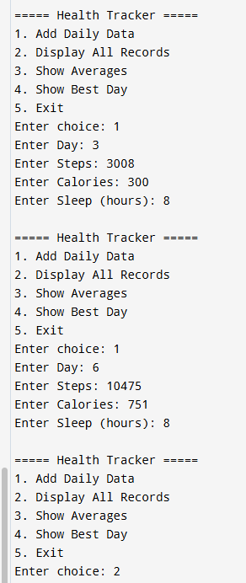

22. Design a system that organises and preserves Vedic texts in digital form, ensuring easy access to verses, rituals, and philosophical content for future generations.

#include <stdio.h>
#include <stdlib.h>
#include <string.h>

struct Node {
char title[50];
char category[20];
char content[200];
struct Node* next;
};

struct Node* last = NULL;

struct Node* createNode(char title[], char category[], char content[]) {
struct Node* newNode = (struct Node*)malloc(sizeof(struct Node));
strcpy(newNode->title, title);
strcpy(newNode->category, category);
strcpy(newNode->content, content);
newNode->next = NULL;
return newNode;
}

void insert(char title[], char category[], char content[]) {
struct Node* newNode = createNode(title, category, content);

if (last == NULL) {
last = newNode;
last->next = last;
} else {
newNode->next = last->next;
last->next = newNode;
last = newNode;
}
}

void display() {
if (last == NULL) {
printf("No data available.\n");
return;
}

struct Node* temp = last->next;

printf("\n--- Vedic Text Records ---\n");
do {
printf("\nTitle: %s\nCategory: %s\nContent: %s\n",
temp->title, temp->category, temp->content);
temp = temp->next;
} while (temp != last->next);
}

void browse() {
if (last == NULL) {
printf("No data available.\n");
return;
}

static struct Node* current = NULL;

if (current == NULL)
current = last->next;
else
current = current->next;

printf("\n--- Browsing ---\n");
printf("Title: %s\nCategory: %s\nContent: %s\n",
current->title, current->category, current->content);
}

void searchByCategory(char category[]) {
if (last == NULL) {
printf("No data available.\n");
return;
}

struct Node* temp = last->next;
int found = 0;

printf("\n--- Search Results (%s) ---\n", category);

do {
if (strcmp(temp->category, category) == 0) {
printf("Title: %s\nContent: %s\n\n",
temp->title, temp->content);
found = 1;
}
temp = temp->next;
} while (temp != last->next);

if (!found)
printf("No matching records found.\n");
}

int main() {
int choice;
char title[50], category[20], content[200];

do {
printf("\n===== Vedic Text Digital System =====\n");
printf("1. Add Text\n");
printf("2. Display All\n");
printf("3. Browse Next (Circular)\n");
printf("4. Search by Category\n");
printf("5. Exit\n");
printf("Enter choice: ");
scanf("%d", &choice);

getchar(); // clear buffer

switch (choice) {
case 1:
printf("Enter Title: ");
fgets(title, sizeof(title), stdin);
title[strcspn(title, "\n")] = 0;

printf("Enter Category (Verse/Ritual/Philosophy): ");
fgets(category, sizeof(category), stdin);
category[strcspn(category, "\n")] = 0;

printf("Enter Content: ");
fgets(content, sizeof(content), stdin);
content[strcspn(content, "\n")] = 0;

insert(title, category, content);
break;

case 2:
display();
break;

case 3:
browse();
break;

case 4:
printf("Enter Category to Search: ");
fgets(category, sizeof(category), stdin);
category[strcspn(category, "\n")] = 0;

searchByCategory(category);
break;

case 5:
printf("Exiting...\n");
break;

default:
printf("Invalid choice!\n");
}

} while (choice != 5);

return 0;
}

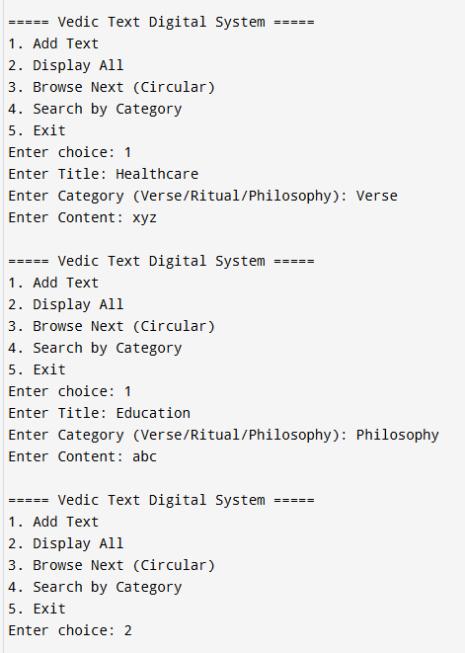

23. System that identifies and classifies common suffixes in Sanskrit words, which is essential for understanding word formation and grammar.

#include <stdio.h>
#include <stdlib.h>
#include <string.h>

struct Node {
char word[50];
char suffix[10];
struct Node* next;
};

struct Node* head = NULL;

void extractSuffix(char word[], char suffix[]) {
int len = strlen(word);

if (len >= 3)
strncpy(suffix, word + len - 3, 3);
else
strcpy(suffix, word);

suffix[3] = '\0';
}

struct Node* createNode(char word[]) {
struct Node* newNode = (struct Node*)malloc(sizeof(struct Node));
strcpy(newNode->word, word);
extractSuffix(word, newNode->suffix);
newNode->next = NULL;
return newNode;
}

void insert(char word[]) {
struct Node* newNode = createNode(word);

if (head == NULL) {
head = newNode;
} else {
struct Node* temp = head;
while (temp->next != NULL)
temp = temp->next;
temp->next = newNode;
}

printf("Word added. Suffix: %s\n", newNode->suffix);
}

void display() {
struct Node* temp = head;

if (temp == NULL) {
printf("No data available.\n");
return;
}

printf("\n--- Words & Suffixes ---\n");
while (temp != NULL) {
printf("Word: %s | Suffix: %s\n", temp->word, temp->suffix);
temp = temp->next;
}
}

void analyze() {
struct Node* temp1 = head;

if (temp1 == NULL) {
printf("No data available.\n");
return;
}

printf("\n--- Suffix Frequency ---\n");

while (temp1 != NULL) {
int count = 0;
struct Node* temp2 = head;

while (temp2 != NULL) {
if (strcmp(temp1->suffix, temp2->suffix) == 0)
count++;
temp2 = temp2->next;
}

printf("Suffix '%s' occurs %d times\n", temp1->suffix, count);

temp1 = temp1->next;
}
}

int main() {
int choice;
char word[50];

do {
printf("\n===== Sanskrit Suffix System =====\n");
printf("1. Add Word\n");
printf("2. Display Words\n");
printf("3. Analyze Suffix Frequency\n");
printf("4. Exit\n");
printf("Enter choice: ");
scanf("%d", &choice);

switch (choice) {
case 1:
printf("Enter Sanskrit Word: ");
scanf("%s", word);
insert(word);
break;

case 2:
display();
break;

case 3:
analyze();
break;

case 4:
printf("Exiting...\n");
break;

default:
printf("Invalid choice!\n");
}

} while (choice != 4);

return 0;
}

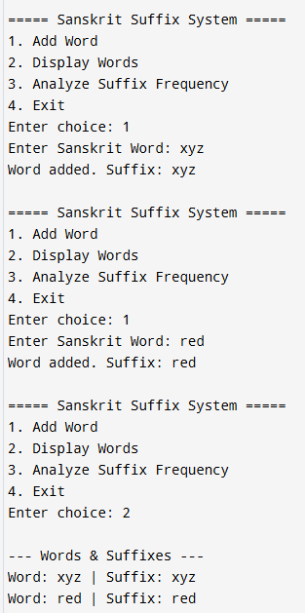

24. Case study on Improving Quality Education through Efficient Data Structures.

#include <stdio.h>
#include <stdlib.h>
#include <string.h>

struct Student {
int id;
char name[50];
float marks;
struct Student* next;
};

struct Student* head = NULL;

struct Student* createNode(int id, char name[], float marks) {
struct Student* newNode = (struct Student*)malloc(sizeof(struct Student));
newNode->id = id;
strcpy(newNode->name, name);
newNode->marks = marks;
newNode->next = NULL;
return newNode;
}

void insert(int id, char name[], float marks) {
struct Student* newNode = createNode(id, name, marks);

if (head == NULL) {
head = newNode;
} else {
struct Student* temp = head;
while (temp->next != NULL)
temp = temp->next;
temp->next = newNode;
}
}

void display() {
struct Student* temp = head;

if (temp == NULL) {
printf("No records available.\n");
return;
}

printf("\n--- Student Records ---\n");
while (temp != NULL) {
printf("ID: %d | Name: %s | Marks: %.2f\n",
temp->id, temp->name, temp->marks);
temp = temp->next;
}
}

void average() {
struct Student* temp = head;
int count = 0;
float total = 0;

while (temp != NULL) {
total += temp->marks;
count++;
temp = temp->next;
}

if (count == 0) {
printf("No data available.\n");
return;
}

printf("\nAverage Marks: %.2f\n", total / count);
}

void topper() {
if (head == NULL) {
printf("No data available.\n");
return;
}

struct Student* temp = head;
struct Student* top = head;

while (temp != NULL) {
if (temp->marks > top->marks) {
top = temp;
}
temp = temp->next;
}

printf("\nTopper -> %s (Marks: %.2f)\n", top->name, top->marks);
}

void lowPerformers() {
struct Student* temp = head;
int count = 0;

while (temp != NULL) {
if (temp->marks < 40) {
count++;
}
temp = temp->next;
}

printf("\nStudents below 40 marks: %d\n", count);
}

int main() {
int choice, id;
char name[50];
float marks;

do {
printf("\n===== Education Quality System =====\n");
printf("1. Add Student\n");
printf("2. Display Students\n");
printf("3. Average Marks\n");
printf("4. Find Topper\n");
printf("5. Count Low Performers\n");
printf("6. Exit\n");
printf("Enter choice: ");
scanf("%d", &choice);

switch (choice) {
case 1:
printf("Enter ID: ");
scanf("%d", &id);
printf("Enter Name: ");
scanf("%s", name);
printf("Enter Marks: ");
scanf("%f", &marks);
insert(id, name, marks);
break;

case 2:
display();
break;

case 3:
average();
break;

case 4:
topper();
break;

case 5:
lowPerformers();
break;

case 6:
printf("Exiting...\n");
break;

default:
printf("Invalid choice!\n");
}

} while (choice != 6);

return 0;
}

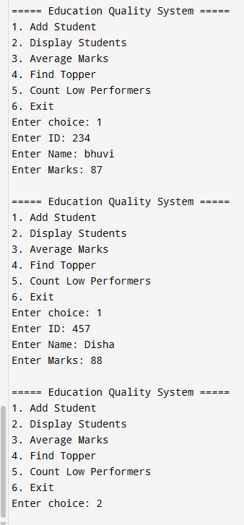

25. System that automates loan processing tasks, including loan eligibility checking, interest estimation, and repayment scheduling.

#include <stdio.h>
#include <stdlib.h>
#include <math.h>
#include <string.h>

struct Loan {
char name[50];
float income;
float loanAmount;
float rate;
int years;
struct Loan* next;
};

struct Loan* head = NULL;

struct Loan* createNode(char name[], float income, float loanAmount, float rate, int years) {
struct Loan* newNode = (struct Loan*)malloc(sizeof(struct Loan));
strcpy(newNode->name, name);
newNode->income = income;
newNode->loanAmount = loanAmount;
newNode->rate = rate;
newNode->years = years;
newNode->next = NULL;
return newNode;
}

void insert(char name[], float income, float loanAmount, float rate, int years) {
struct Loan* newNode = createNode(name, income, loanAmount, rate, years);

if (head == NULL) {
head = newNode;
} else {
struct Loan* temp = head;
while (temp->next != NULL)
temp = temp->next;
temp->next = newNode;
}
}

void checkEligibility(struct Loan* loan) {
if (loan->income * 10 >= loan->loanAmount)
printf("Eligible for loan\n");
else
printf("Not eligible for loan\n");
}

float calculateEMI(float P, float R, int N) {
float monthlyRate = R / (12 * 100);
int months = N * 12;

float emi = (P * monthlyRate * pow(1 + monthlyRate, months)) /
(pow(1 + monthlyRate, months) - 1);

return emi;
}

void repaymentSchedule(float emi, int months) {
printf("\n--- Repayment Schedule ---\n");
for (int i = 1; i <= months; i++) {
printf("Month %d: Payment = %.2f\n", i, emi);
}
}

void processLoans() {
struct Loan* temp = head;

if (temp == NULL) {
printf("No loan applications.\n");
return;
}

while (temp != NULL) {
printf("\nApplicant: %s\n", temp->name);

checkEligibility(temp);

float emi = calculateEMI(temp->loanAmount, temp->rate, temp->years);
printf("Monthly EMI: %.2f\n", emi);

repaymentSchedule(emi, temp->years * 12);

temp = temp->next;
}
}

int main() {
int choice, years;
float income, loanAmount, rate;
char name[50];

do {
printf("\n===== Loan Processing System =====\n");
printf("1. Apply for Loan\n");
printf("2. Process Loans\n");
printf("3. Exit\n");
printf("Enter choice: ");
scanf("%d", &choice);

switch (choice) {
case 1:
printf("Enter Name: ");
scanf("%s", name);
printf("Enter Monthly Income: ");
scanf("%f", &income);
printf("Enter Loan Amount: ");
scanf("%f", &loanAmount);
printf("Enter Interest Rate (annual %%): ");
scanf("%f", &rate);
printf("Enter Loan Duration (years): ");
scanf("%d", &years);

insert(name, income, loanAmount, rate, years);
break;

case 2:
processLoans();
break;

case 3:
printf("Exiting...\n");
break;

default:
printf("Invalid choice!\n");
}

} while (choice != 3);

return 0;
}

